1. **OFFER section**

* Principle: when the Sales sets the Opportunity in the Pipeline Phase to position *3. Offer*, then the CRM sends it to OFFER section with an alert;

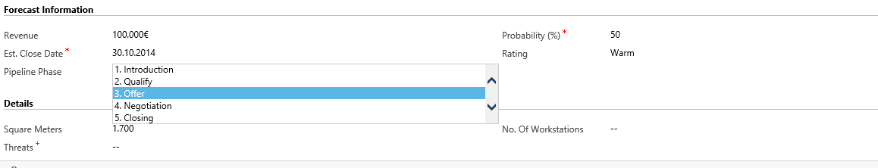

* User: Head of OFFER Department;
* Necessary fields in this section:
  + - Offer value for M&E works;                                        GP for M&E works;                         Author of M&E offer;
    - Offer value for Construction works;                        GP for Construction works;         Author of Construction offer;
    - Other works;                                                                     GP for other works;                        Author of Other works offer;
    - TOTAL OFFER VALUE  – *to be auto calculated as the sum of all the above;*
    - GP for COMPLETE OFFER;
    - Standard execution term of the project;
    - Notes/Comments.